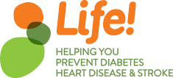
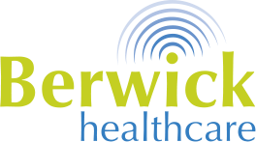

2018 Group Dates
Thank you for your interest in The Life! Program. You’ve taken the first step in prevention, healing and discovering the new you! The Life! Program will help you reach your goals.
Did you know?
- Every day approximately 280 people aged over 25 develop Diabetes.
- Every 12 Minutes someone dies of Cardiovascular Disease.
- One in every 6 people is likely to suffer a stroke.
Don’t let this be you! Sign up for one of our 2018 Group Sessions today.

Group 1 2018 Sessions-
- Monday 5th February 6:45pm – 8:30pm
- Monday 19th February 6:45pm – 8:30pm
- Monday 5th March 6:45pm – 8:30pm
- Monday 19th March 6:45pm – 8:30pm
- Monday 18th June 6:45pm – 8:30pm
Group 2 2018 Sessions-
- Monday 16th April 6:45pm – 8:30pm
- Monday 30th April 6:45pm – 8:30pm
- Monday 14th May 6:45pm – 8:30pm
- Monday 28th May 6:45pm – 8:30pm
- Monday 27th August 6:45pm – 8:30pm
Group 3 2018 Sessions-
- Monday 8th October 6:45pm – 8:30pm
- Monday 22nd October 6:45pm – 8:30pm
- Monday 5th November 6:45pm – 8:30pm
- Monday 19th November 6:45pm – 8:30pm
- Monday 18th February 2019 6:45pm – 8:30pm

All sessions are held on site at Berwick Healthcare - 76 Clyde Road, Berwick 3806. Sign up at Reception.

